**LAB TASK**

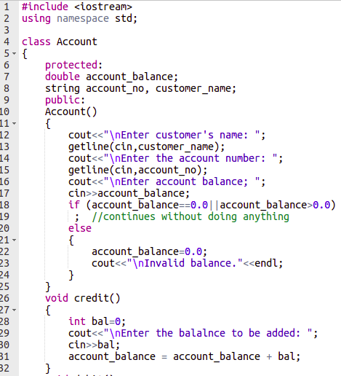

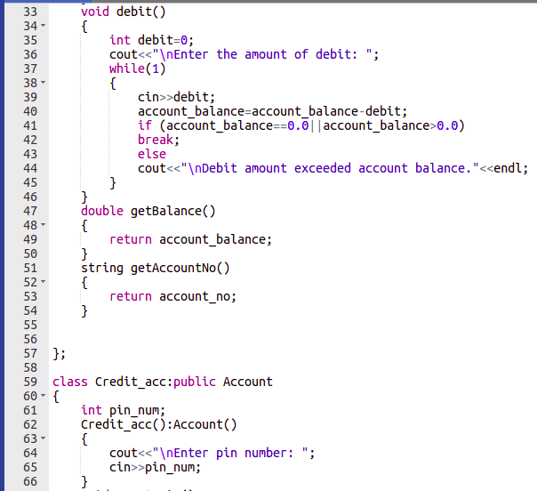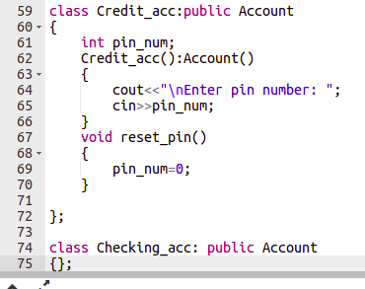

**Conclusion:**

In this lab I revised all the concepts of previous labs including polymorphism, dynamic memory allocation and many more.